**Database Design Examples**

**Example 1:**

Primary Key and Foreign Key

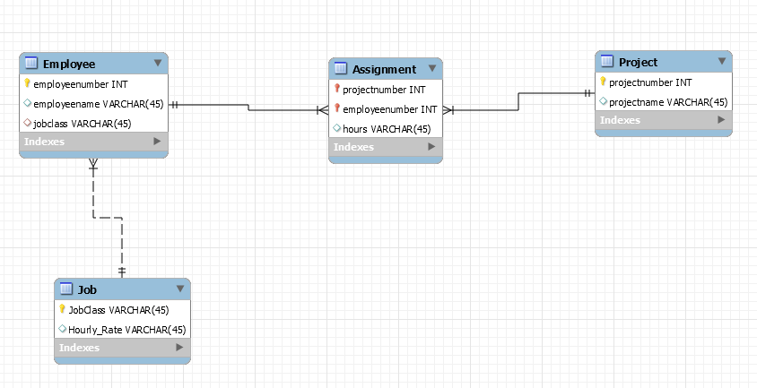

Foreign Key

**Solid vs. Dashed Lines:** When a foreign key in the child (i.e., table that is on the many site of a relationship) serves as part of a composite primary key then we refer to that child as a dependent entity. In such cases, we refer to the parent(i.e., table that is on the one side of a relationship) as an independent entity. We use a solid line to connect an independent entity to a dependent entity. If the foreign key in the child (i.e., table that is on the many site of a relationship) does not serve as a part of a composite primary key, we say that child is an independent entity. We connect two independent entities by using a dashed line.

Primary Key and Foreign Key

**Example 2:**

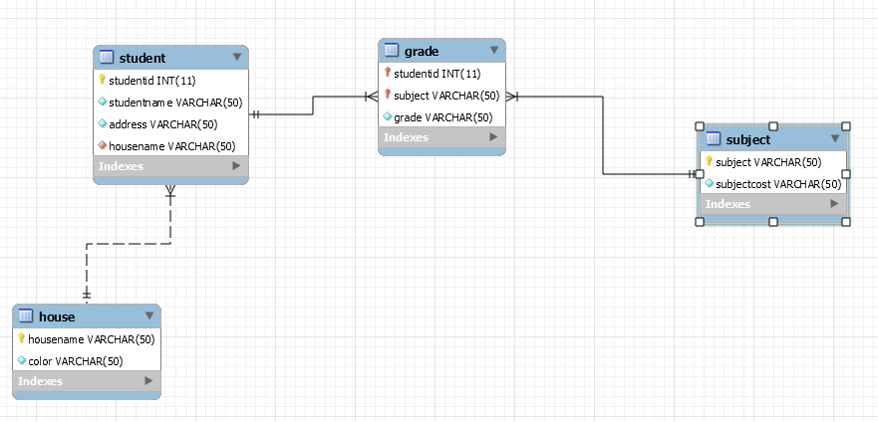

Foreign Key

**Example 3:**

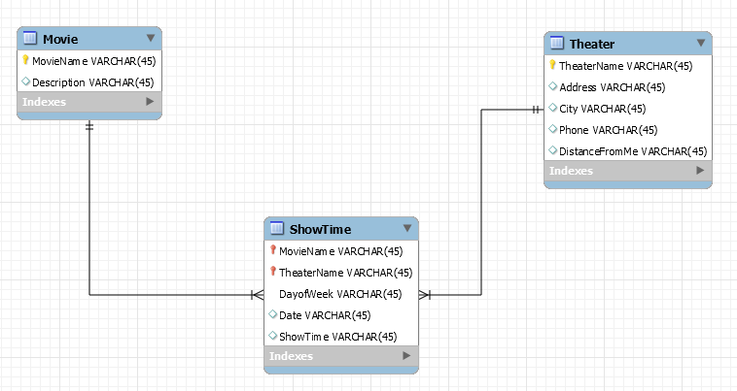

Primary Key and Foreign Key